**ER Diagram:**

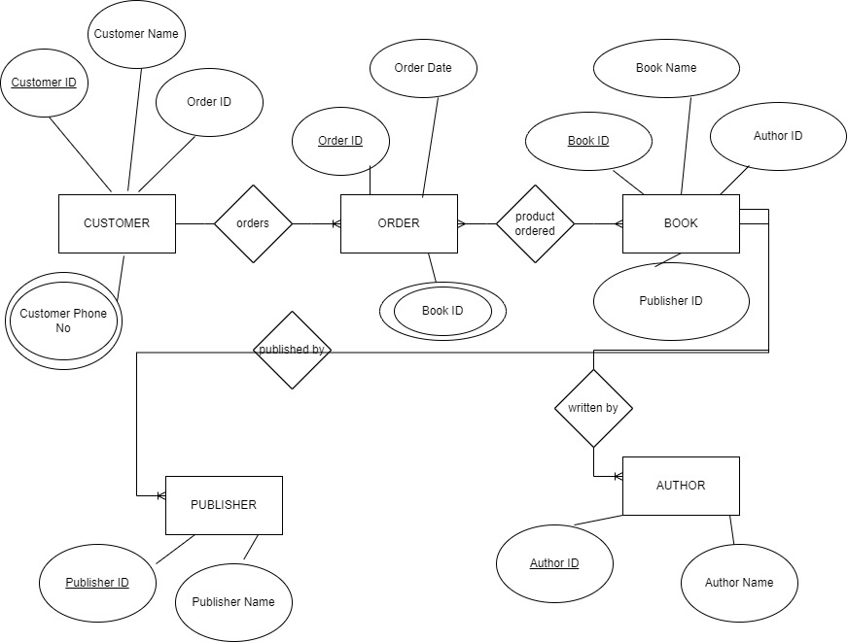

**Normalization:**

1NF:

Customer table has a multivalued attribute called Customer Phone No. A separate table has to be created in order to have atomic entries and normalize the table to 1NF. Shown below:

Table name-Customer_phoneno

|  |  |
| --- | --- |
| Customer ID | Customer Phone No |
| 123456 | 8861730098 |
| 123456 | 9591886173 |

Order table also needs to be normalized to 1NF as it has Book ID as multivalued attribute.

Table name-Order_bookid

|  |  |
| --- | --- |
| Order ID | Book ID |
| 123 | 58766 |
| 123 | 90874 |

Table Book, Author and Publisher are in 1NF. After creation of new tables, Customer table and Order table are in 1NF as well.

2NF:  
Customer ID and Order Id form a superkey in Customer table. All attributed of the entity are fully functionally dependent on the superkey only. The superkey is not dependent on any candidate key.

Order ID and Book Id form a superkey in Order table. All attributes of the entity are fully functionally dependent on the superkey only. The superkey is not dependent on any candidate key.

Book ID, Publisher ID, Author ID form a superkey in Book table. All attributes of the entity are fully functionally dependent on the superkey only. The superkey is not dependent on any candidate key.

Publisher ID is the primary key in Publisher table. All attributes are fully functionally dependent on it. The primary key is not dependent on any candidate key.

Author ID is the primary key in Author table. All attributes are fully functionally dependent on it. The primary key is not dependent on any candidate key.

Hence, all tables are in 2NF form now.

3NF:

The superkeys and primary keys do not have any element which is part of a candidate key in all of the above 5 tables.

Thus, all tables are free of transitive dependencies and are in 3NF.